**Cairo University Faculty of Computers and Artificial Intelligence**

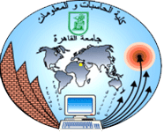

**Advanced SE**

**Software design specification document**

**2022**

**Project Team**

|  |  |  |
| --- | --- | --- |
| **ID** | **Name** | **Email** |
| 20200126 | Ganna Allah Emad AbdElkhalek | gannaemadd@gmail.com |
| 20200605 | Nour Muhammed Anwar | nourmuhammed36@gmail.com |
| 20200446 | Mohamed Samy Atwa | hellosamysamy4@gmail.com |
| 20200231 | Salma Hany Gamal | salma.anany10@gmail.com |

**Class diagram**

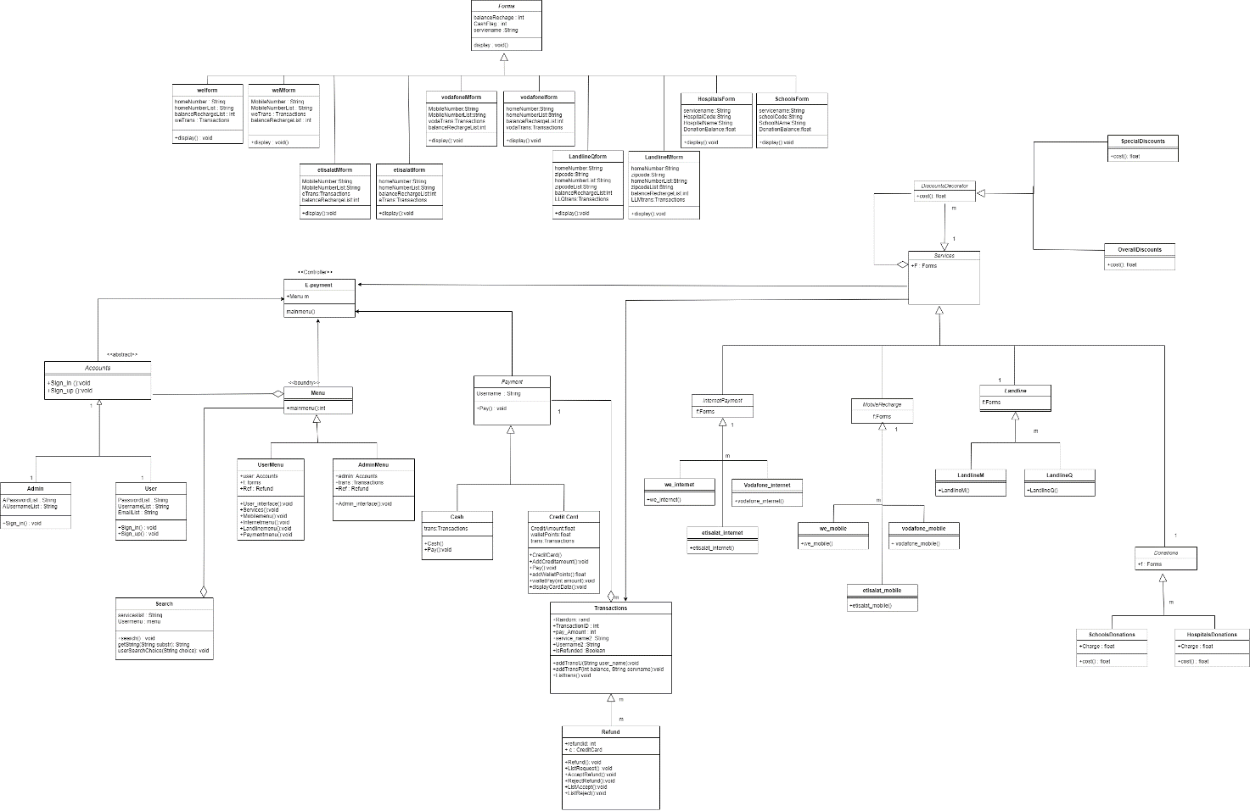

# 

# Class diagram Explanation

* Decorator pattern in the discount as the decorator pattern is  structural design pattern so it will allow us to add new behaviors which are the specific and overall discounts in our system to the service objects
* Factory design pattern in the services part as we will create many types of services but they belong to one single family so the factory is well used here as it is a creational design pattern that provides an interface for creating objects in a superclass, but allows subclasses to change the type of objects that will be created.
* Observer pattern is used in notifying user when he requests to refund a transaction and the transaction request accepted or rejected
* Strategy design pattern is behavioral design pattern that is used in determining the payment method by user at runtime for different methods strategy (cash if acceptable - credit card -wallet ) so we will be able to define a family of payment algorithms, put each of them into a separate class, and make their objects interchangeable.
* Template design pattern is also used in authentication and many methods in different classes

# Sequence diagram Design

1. Search sequence diagram:

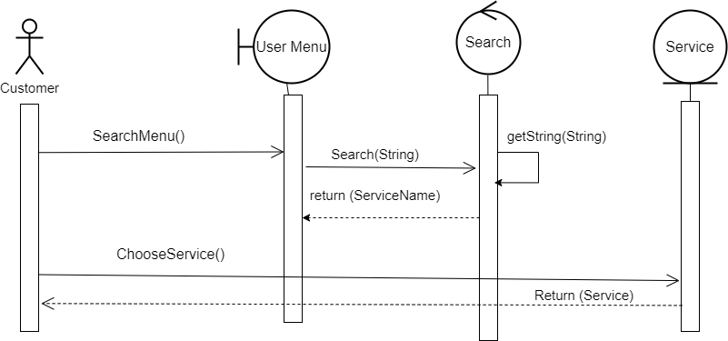

2) Pay With Credit Card sequence diagram:

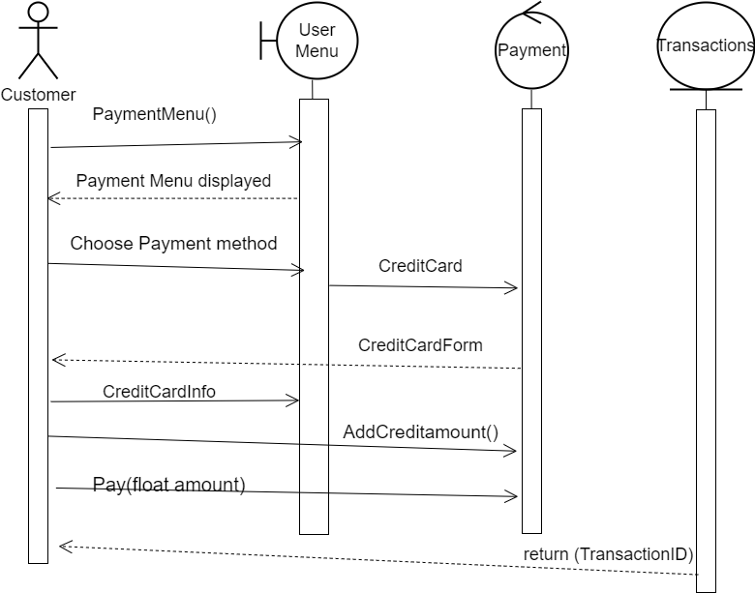

3) Sign In Sequence Diagram:

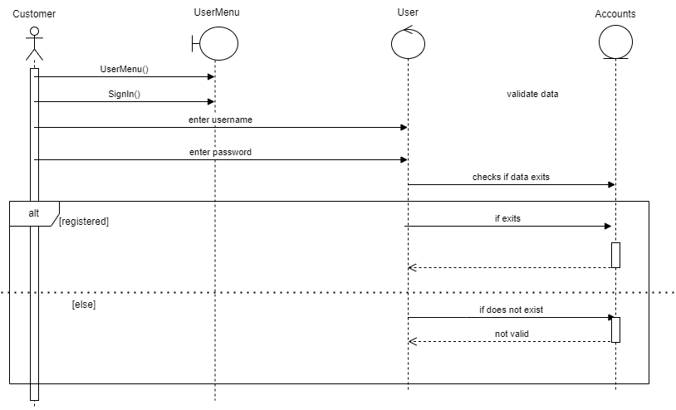

4) Sign Up Sequence Diagram:

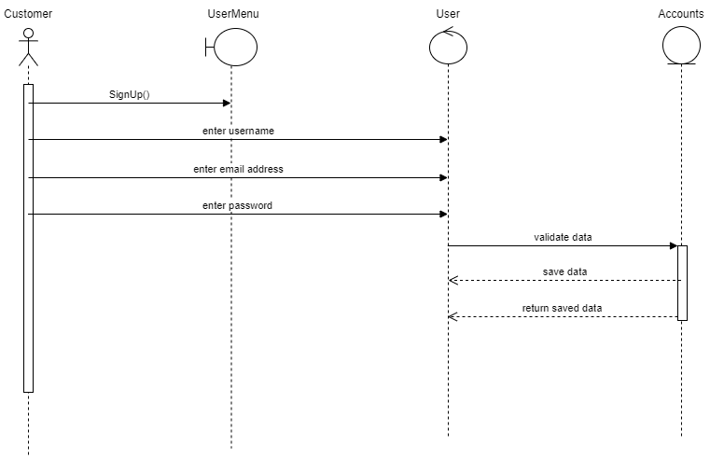

5) Refund Transaction Sequence Diagram:

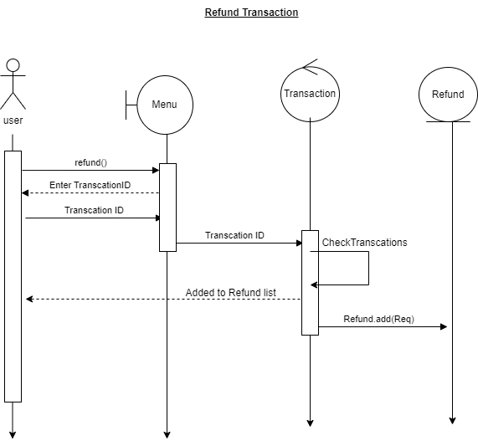

6) Accept Refund Sequence Diagram:

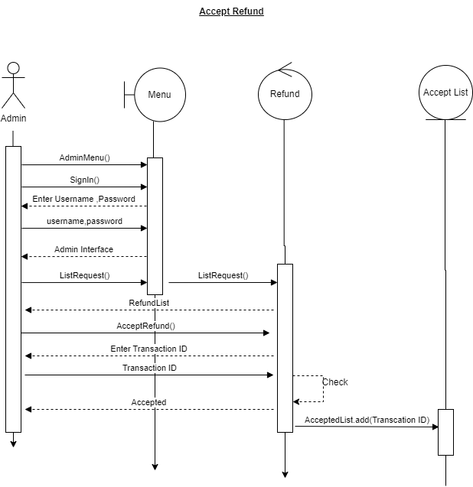

7) Add Money To Wallet Sequence Diagram:

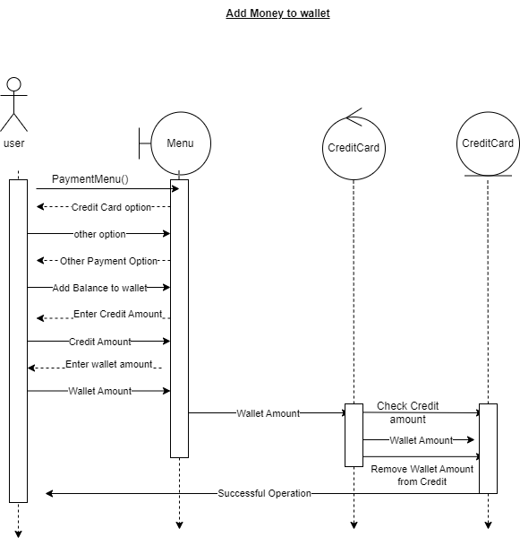

8) Discount Sequence diagram:

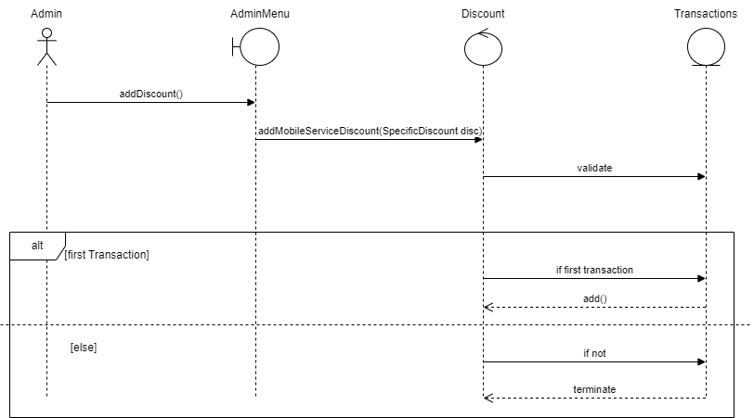

# 

# Github repository link:

* https://github.com/nourmuhammed20/Fawary_E-Payment